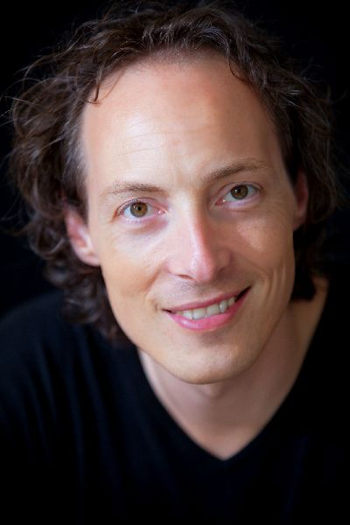

Jan-Willem Schaafsma
Valkenboslaan 221
2563 CW DEN HAAG
+31 6 43901059
jwschaaf@gmail.com
www.janwillemschaafsma.com

Dutch tenor Jan-Willem Schaafsma completed his studies at the Royal Conservatory (The Hague) and received his Master-degree at the Dutch National Opera Academy (DNOA). He is known for his versatility and diversity in style and repertoire.

In DNOA he sang several roles, among which Lysander (A Midsummer Night’s Dream, Britten) and La Théière/La Rainette (L’enfant et les Sortilèges, Ravel), focusing on the character Fach and comprimario roles. After his graduation he sang Dr. Cajus (Falstaff, Verdi) in the IVAI festival, Tel Aviv, conducted by maestro Paul Nadler.
Main parts in his repertoire include Phaeton (Phaeton, Lully), Candide (Candide, Bernstein) and Acis (Acis & Galatea, Handel), all in tours throughout The Netherlands.
At the Nederlandse Reisopera (Dutch Touring Opera) he sang Candide (Candide, Bernstein), Belmonte (Die Entführung aus dem Serail, Mozart) and La Barca (Banchieri).
At the Dutch National Opera (DNO) he performed in Platée (Rameau), Deidamia (Handel) and Die Meistersinger von Nürnberg (Wagner). Recently, he performed Gastone in La Traviata (Verdi), with Opera Zuid; Pong (Turandot, Puccini) and Lenski (Jevgeni Onegin, Tchaikovsky), both concert versions.
In 2018 he performed Laërte in Thomas’ Hamlet with Opera2day, touring 25 performances in The Netherlands.
Future performances include Sieben Todsünden (Weill) and The Nose (Shostakovich), with the Royal Concertgebouw Orchestra, and a main part in the newly written opera Dejima, in Tokyo.
Also, he will make his debut with the Nederlandse Bachvereniging in their new Bach-programme Café Zimmermann, in the spring of 2019.

In concert, he has worked with Ed Spanjaard (Stabat Mater, Dvořak) and with Reinbert de Leeuw, performing the arias of the Matthäus Passion (Bach) both with the Limburgs Symfonie Orkest. His oratoriorepertoire is extensive and ranges from Bach and Handel to Britten and Berio.

Mr. Schaafsma has worked with conductors such as Edo de Waart, Ed Spanjaard, Kenneth Montgomery, Reinbert de Leeuw, José Esandi, Jeremy Carnall, Ivor Bolton and Gabriel Garrido.

